MEDICAL EXAMINATION REPORT
FOR A PRIVATE HIRE/HACKNEY CARRIAGE DRIVER LICENCE

Notes for Applicants

1. The attached Certificate must be received by the Council within 3 months of the Doctor signing it and need only be completed on the:

- First application for a licence
- Age 45, and then every 5 years until age 65
- Age 65, and every year thereafter
- Any other times when required by the Council

2. Payment for all medical reports is the applicant’s responsibility.

3. The Council apply Group 2 medical standards to all applicants/licence holders. More information on Group 2 medical standards can be accessed at www.gov.uk and reading leaflet INF4D .

Notes for Medical Practitioner

1. When completing this medical form and certificate, please have regard to the DVLA’s "At a Glance" and the Medical Commission on Accident Prevention booklet "Medical Aspects of Fitness to Drive". The Council apply Group 2 medical standards for suitability to drive licensed vehicles.

2. Applicants who may be symptom free at the time of the examination should be advised that if, in future, they develop symptoms of a condition which could affect safe driving and they hold any type of licence they must inform the Council.

3. The main purpose of the certificate is to ascertain that the client is fit to drive and any additional information should only be disclosed to advise on recommended length of fitness (e.g. insulin dependant diabetic) or workplace adjustments required under the Disability Discrimination Act 1995.

Group 2 Medical Standards

Medical standards for drivers of passenger carrying vehicles are higher than those required for car drivers. The following conditions are likely to be a bar to the holding of a private hire or hackney carriage driver licence:

1. Epilepsy or liability to epileptic attacks
Applicants must have been free of epileptic seizures for at least the last 10 years and have not taken any anti-epilepsy medication during this 10 year period. The Council is likely to refuse or revoke a licence if these conditions cannot be met.

2. Diabetes
Applicants with insulin treated diabetes may NOT obtain a licence to be a Private Hire or Hackney Carriage Driver UNLESS they held a Private Hire or Hackney Carriage Driver Licence valid on 1 April 1991 and the Council had knowledge of the insulin treatment before 1 January 1991.

3. Eyesight
All applicants must be able to read in good a registration mark fixed to a vehicle registered under current standards at a distance of 20 metres with letters and numbers 79 mm high by 50 mm wide on a car registered since 1 September 2001 or at a distance of 20.5 metres with letters and numbers 79 mm high by 57 mm wide on a car registered before 1 September 2001 and the visual acuity must be at least Snellen 6/12 or better.

In addition applicants must have:
- A visual acuity of at least 6/7.5 (decimal Snellen equivalent 0.8) in the better eye.
- A visual acuity of at least 6/60 (decimal Snellen equivalent 0.1) in the worse eye.
- This may be achieved with or without glassess or contact lenses.
- If glasses (not contact lenses) are worn for driving, the spectacle prescription of either lens used must not be of a corrective power greater than plus 8 (+8) dioptres in any meridian.

Applicants are also barred from holding a licence if they have:
- Uncontrolled diplopia (double vision)
- Or do not have a normal binocular field of vision.

4. Other medical conditions
In addition applicants are likely to be refused a licence if they are unable to meet thr national recommended guidelines in the following cases:

- Within three months of myocardial infarction, an episode of unstable angina, CABG or coronary angioplasty.
- A significant disturbance of cardiac rhythm occurring within the past five years unless special criteria are met.
- Suffering from or receiving medication for angina or heart failure.
- Hypertension where the blood pressure is persistently 180 systolic or more and/or 100 diastolic or more.
- A stroke or TIA within the last twelve months.
- Unexplained loss of consciousness within the past five years.
- Meniere's and other conditions causing disabling vertigo within the past twelve months aand with a liability to recurrence.
- Recent severe head injury with serious continuing after effects or major brain surgery.
- Parkinson's disease, multiple sclerosis or other chronic neurological disorders with symptoms likely to affect limb power and co-ordination.
- Suffering from a psychotic illness in the past three years or suffering from dementia.
- Alcohol dependency or miuse or persistent drug or substance misuse or dependency in the past three years.
- Insuperable difficulty in communiction by telehone in an emergency.
- If major psychotropic or neuroleptic medication is being taken.
- Any malignant condition within the last two years likely to metastasise to the brain.
- Any other serious medical condition likely to affect the safe driving of a passenger carrying vehicle.

SECTION A

Applicant’s Details

Surname:

Forename(s):

Address:

Post Code:

Age:
Date of Birth:

Home Tel No:
Mobile No:

Applicant’s Registered Doctor’s Details

GP/Practice Name:

Address:

Telephone Number:

E mail address:

SECTION B
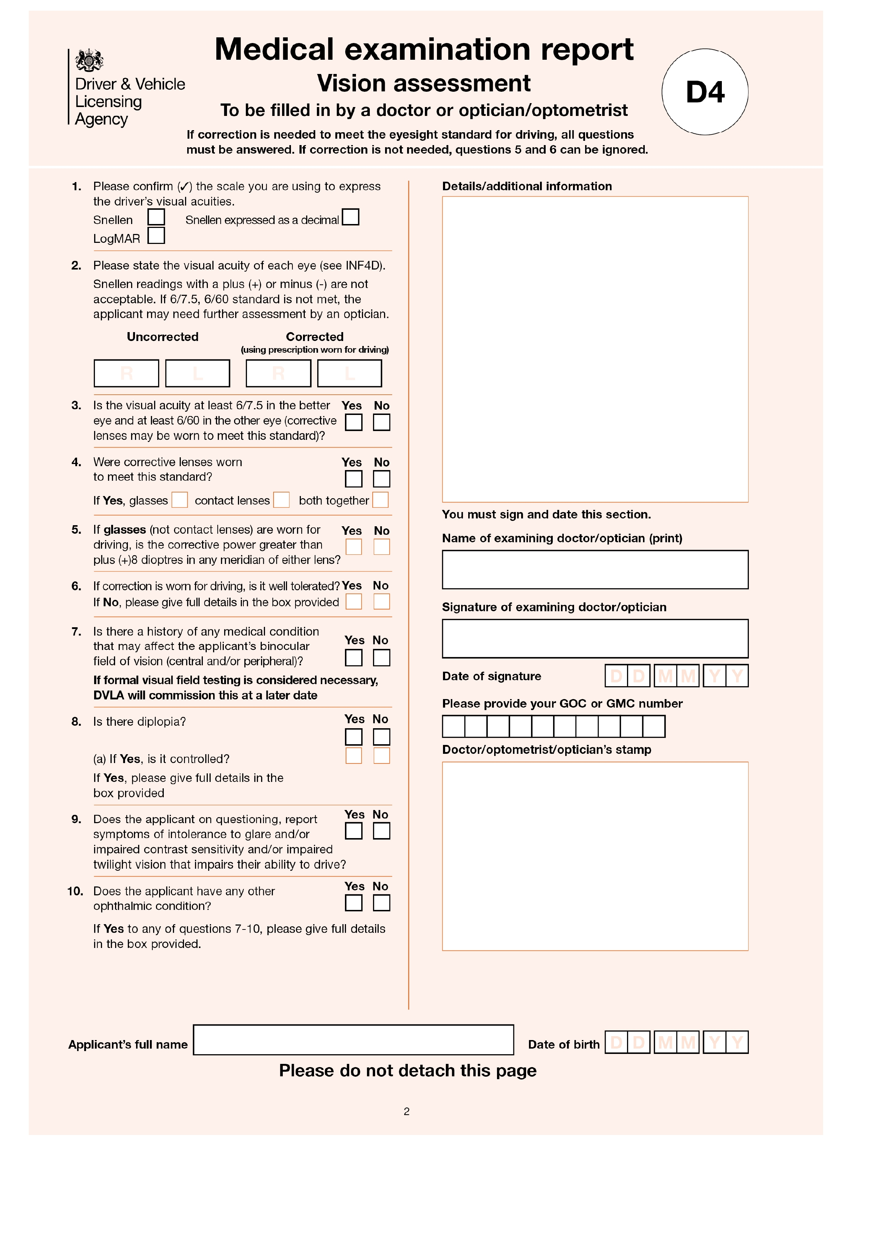
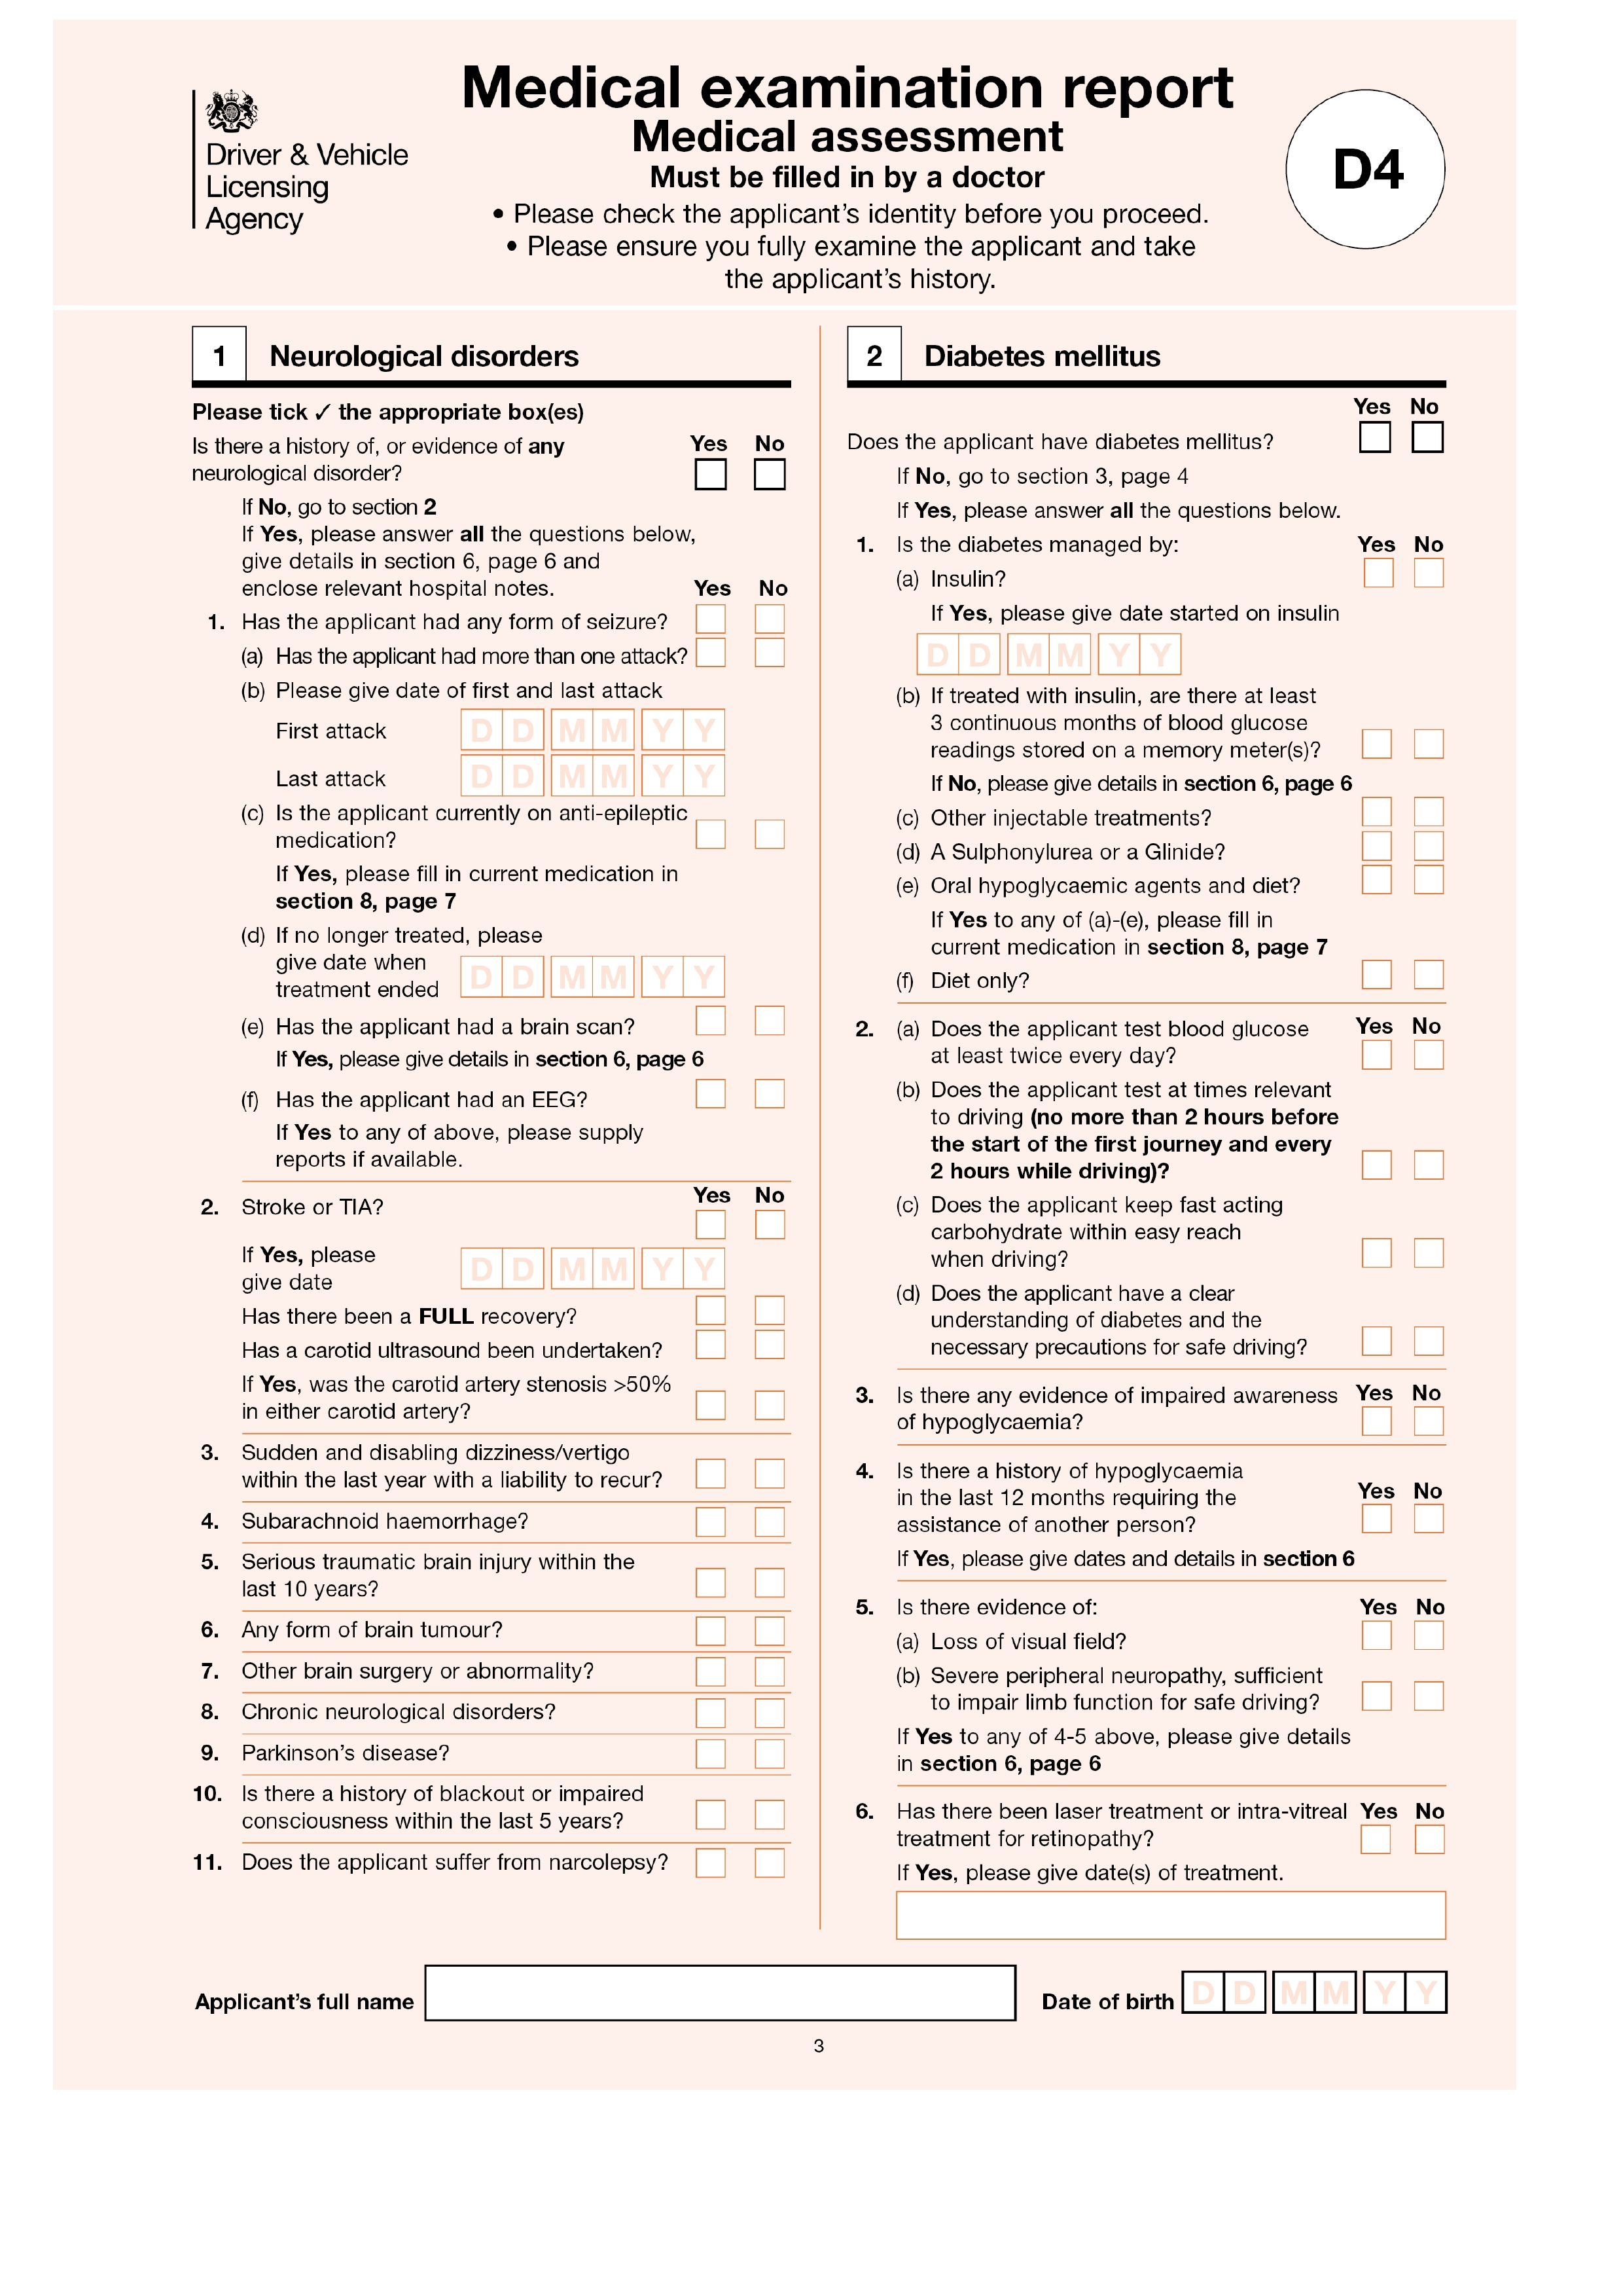
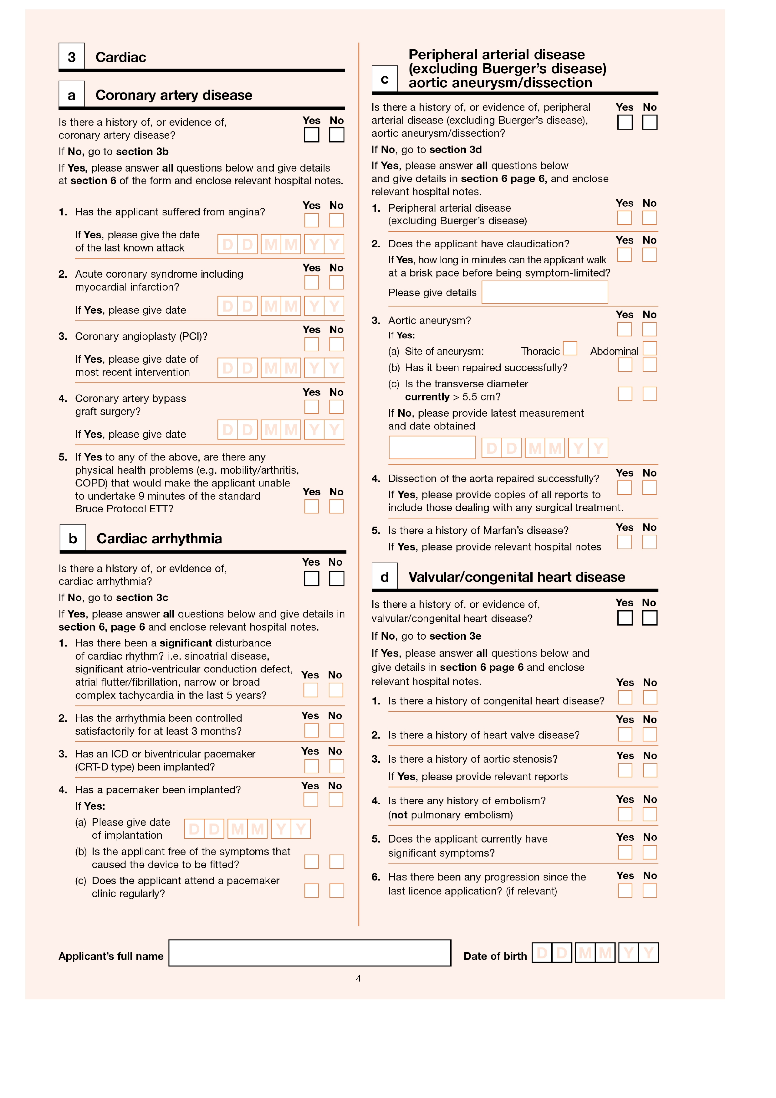
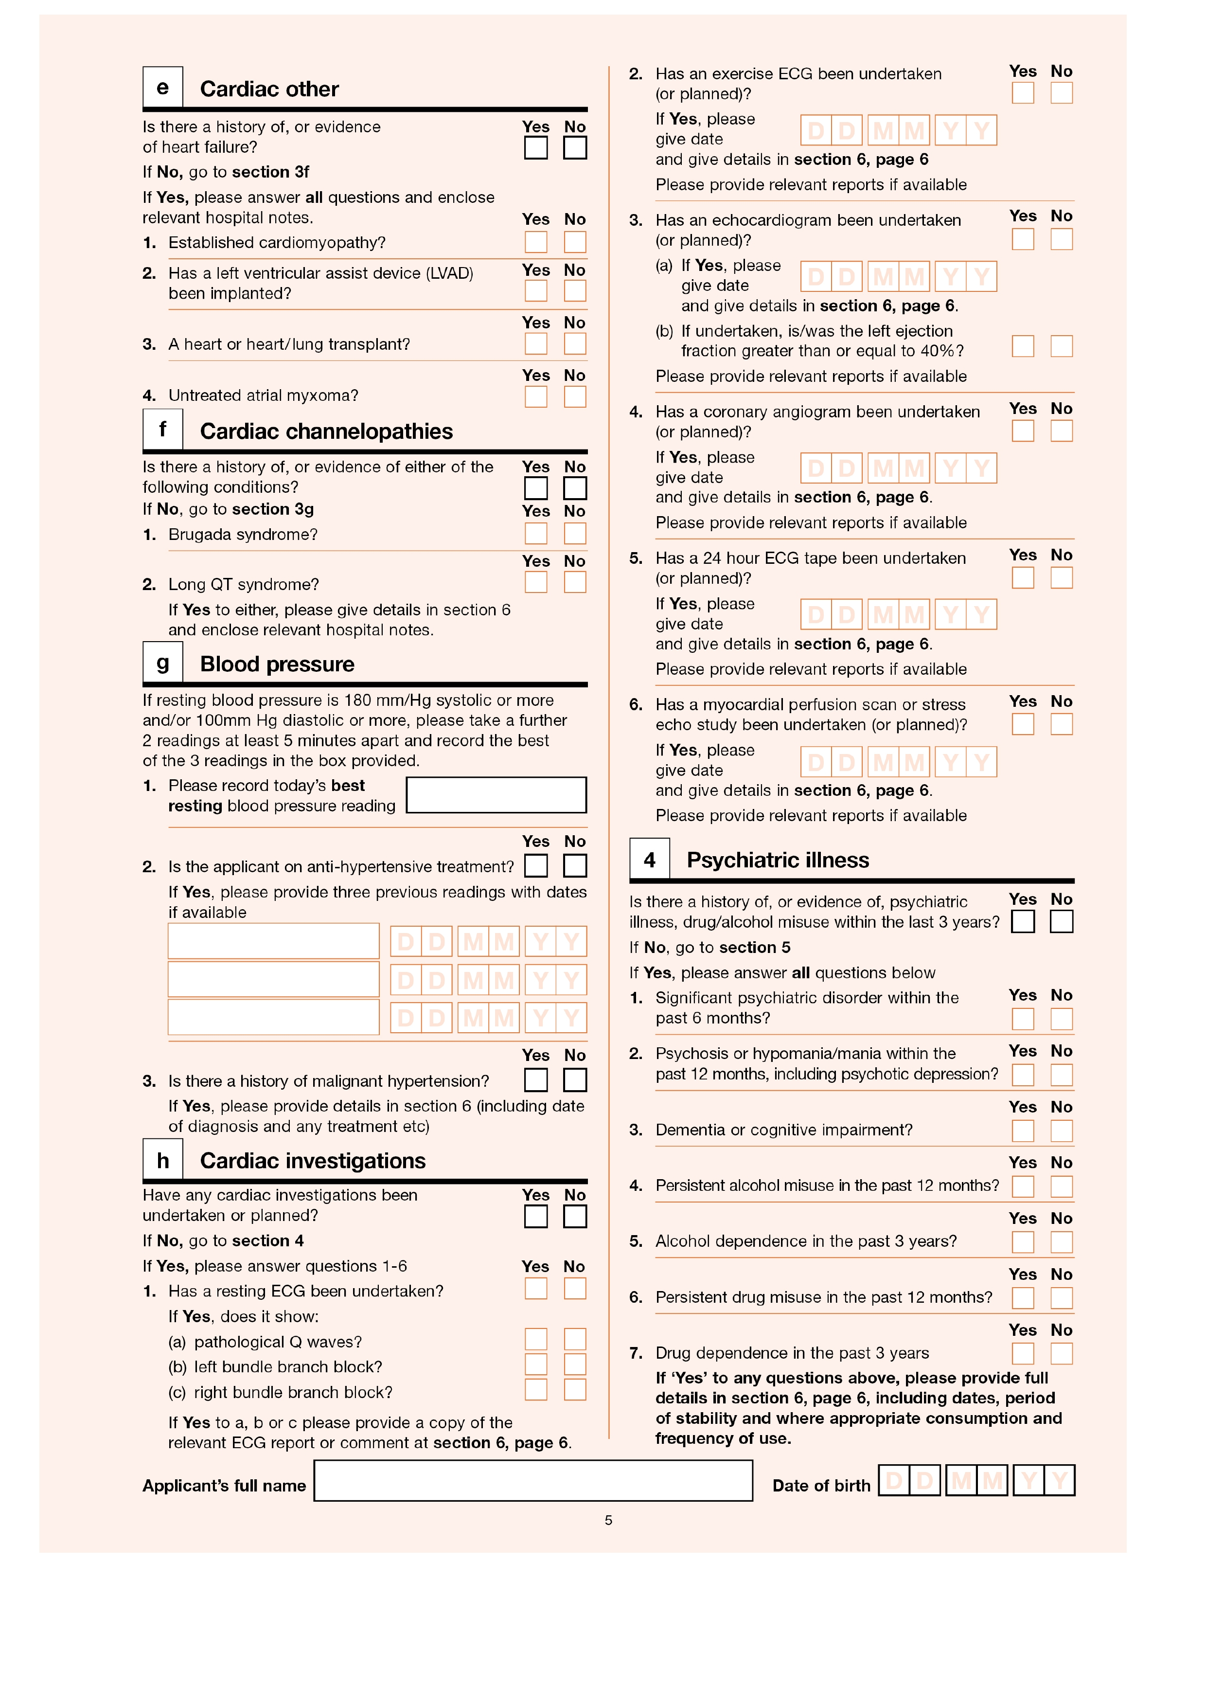
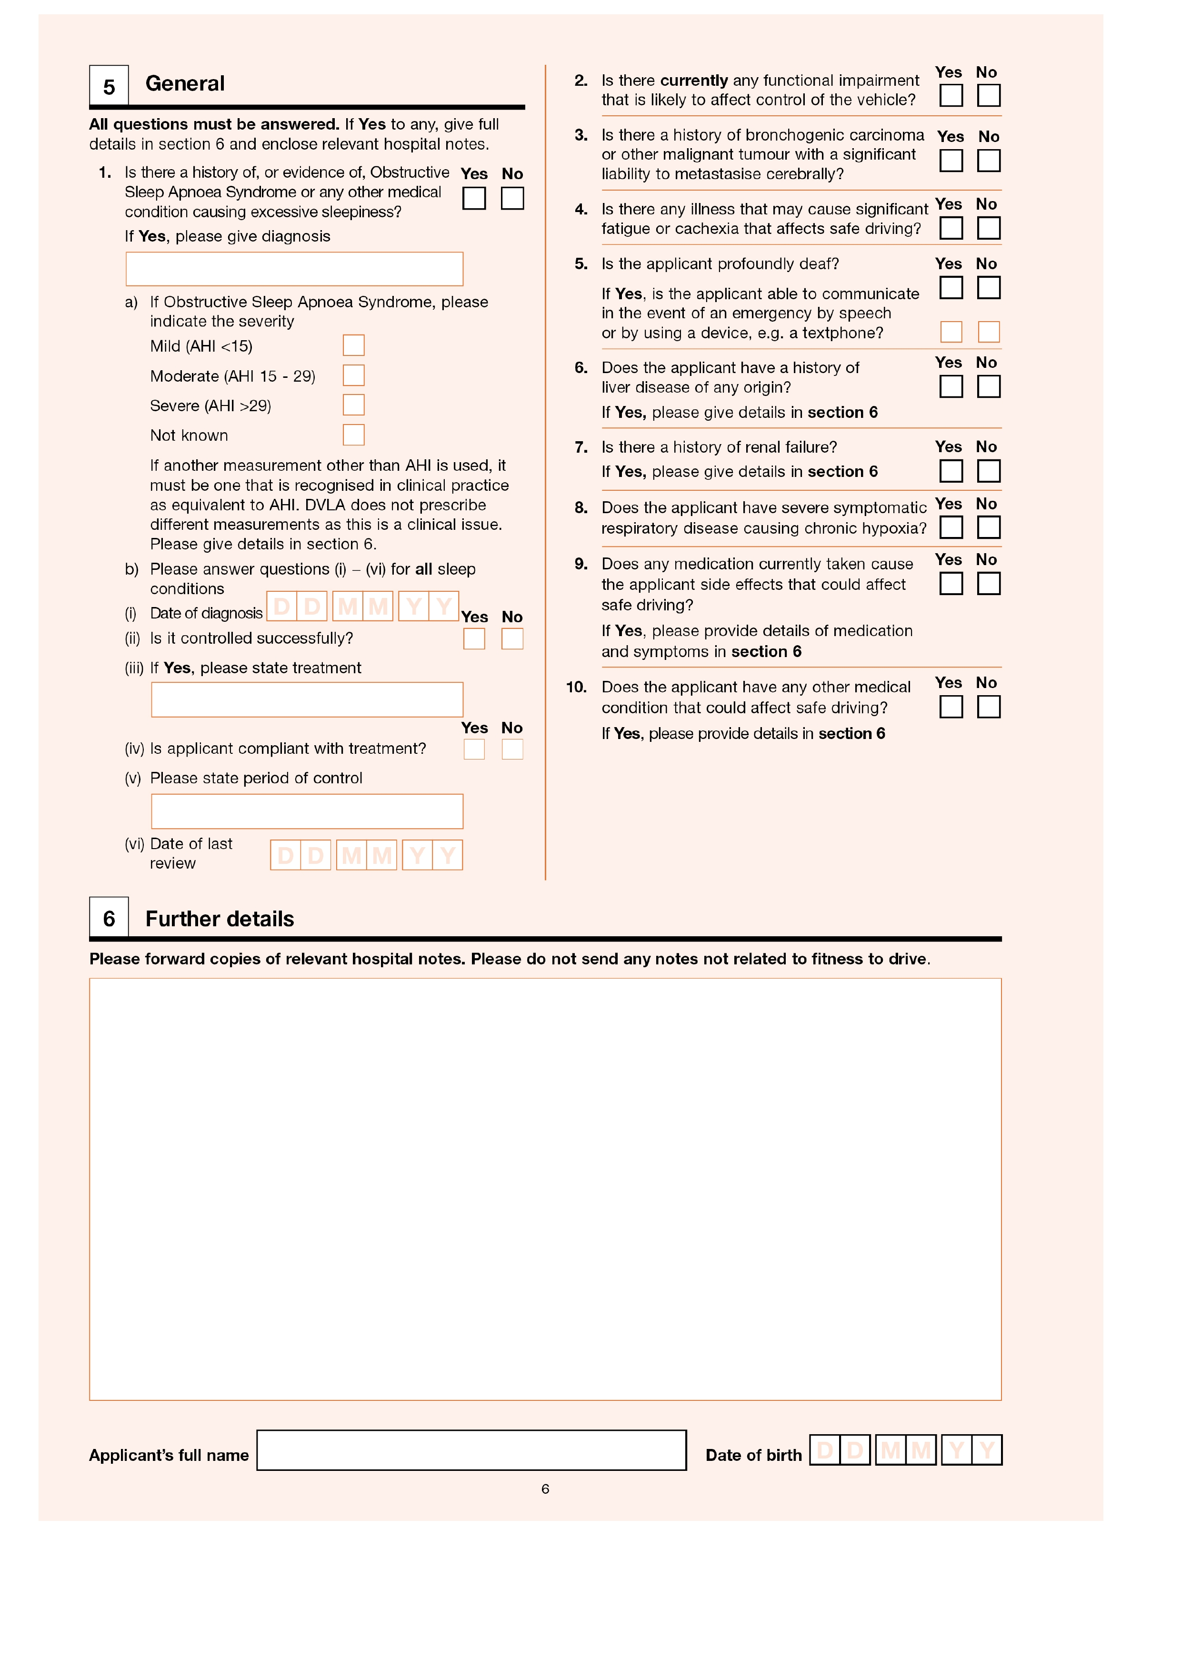
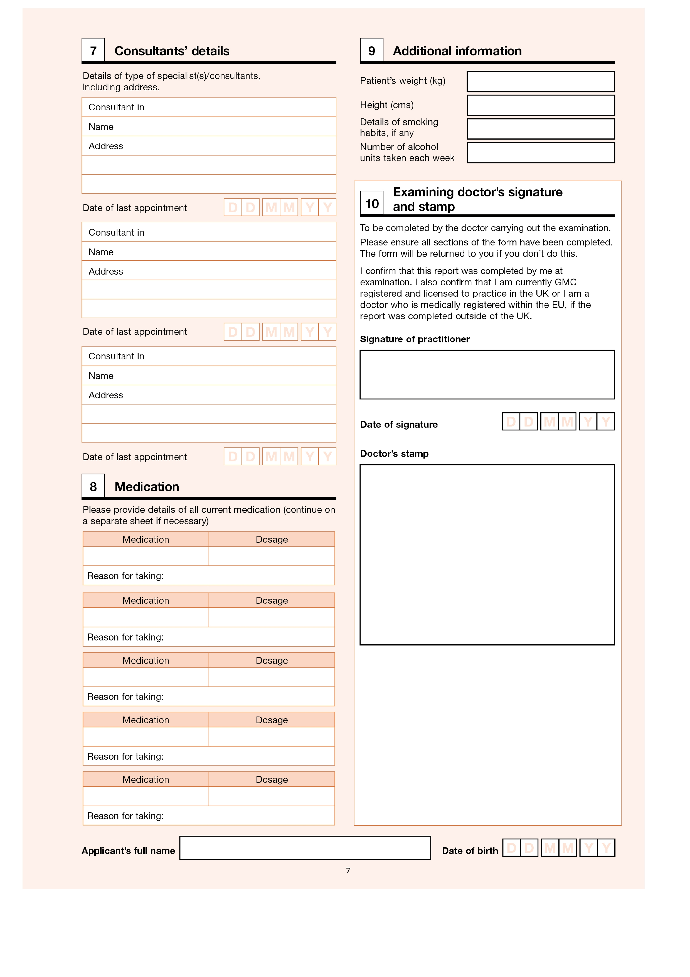

CERTIFICATE OF FITNESS TO DRIVE
A PRIVATE HIRE OR HACKNEY CARRIAGE VEHICLE

Applicant Name: ______________________________________________

Date of Birth: __________________

Being a registered Medical Practitioner who is competent in undertaking DVLA Group 2 medical examinations, I have today examined the above applicant. I have examined the applicant medically to DVLA Group 2 medical standards and having regard to the DVLA’s “At a Glance” and the Medical Commission on Accident Preventions booklet “Medical Aspects of Fitness to Drive” I consider the above applicant *;

*Please tick relevant box

Is FIT to drive a Private Hire or Hackney Carriage Vehicle to Group 2 Standards

Is UNFIT to drive a Private Hire or Hackney Carriage Vehicle

The following additional information is to be disclosed to the Licensing Authority (see page 1 note B) in relation to any form of workplace adjustments under the Disability Discrimination Act and / or the period of an applicants fitness to drive (e.g. insulin dependent diabetic).

______________________________________________________________________________

______________________________________________________________________________
(Any additional information not relevant to the above two instances must not be disclosed. The Medical Practitioner must determine from the medical completed whether the applicant is or is not fit to drive under Group 2 standards)

EXAMINING DOCTORS DETAILS

Name: ________________________________________

Surgery Address: _____________________________________________________________

_____________________________________________________________________________

Phone: _________________________________________ Email: ______________________

Signed: __________________________________ Date: _____________________________

GMC Registration Number: Surgery Stamp:

